**REPORT**

Florida International University  
MPAS and Golden Drum Scholarships  
Student Headcount Profile

**Executive Summary**

The MPAS Scholarship and Golden Drum Scholarship are available to all high school seniors in Miami-Dade and Broward counties who are a U.S Citizen or resident alien and have an unweighted high school GPA of 3.0 or better(Golden Drum) and 2.75 or better (MPAS). While students can apply to both scholarships, they may only be the recipient of one scholarship. This report looks at the headcount and demographics of First Time in College (FTIC) recipients of the MPAS and Golden Drum Scholarships.

Of the 150 total scholarship recipients from 2016-2017 to 2020-2021:

|  |  |
| --- | --- |
| Golden Drum Scholarship[1] | MPAS Scholarship |
| 29 Female vs 17 Male | 68 Female vs 36 Male |
| 69.6% (32) Hispanic recipients | 54.6% (57) Hispanic recipients |
| 89.1 (41) Non-First Generation | 70.2% (73) Non-First Generation |
| 65.2% (30) Pell grant received | 70.2% (73) Pell grant received |
| 97.8 (45) had a GPA greater than 2.0 | 97.9% (94) of FT FTIC had a GPA greater than 2.0 |
| 97.8% (45) retained in 2nd year | 97.9% (94) of FT FTIC retained in 2nd year |
| 100.0% (12) 4-year graduation rate in 2017-2018 cohort year | 82.8% (24) overall FT FTIC 4-year graduation rate for 2016-2017 and 2017-2018 cohort years |

**Golden Drum Scholarship Analysis**

* The Golden Drum Scholarship recipients are mostly Female, except in the 2020-2021 cohort year, where they account for 50.0%
* The 2019-2020 cohort year had the largest group of Female scholarship recipients (10), double that of Male recipients (5)

Table 1: FT FTIC Golden Drum Scholarship Recipients by Gender



* 69.6% (32) of scholarship recipients are Hispanic, followed by 15.2% (7) of Black or African American students
* Only 6.5% (3) of scholarship recipients are Asian

Table 2: FT FTIC Golden Drum Scholarship Recipients by Race/Ethnicity



* 45.7% (21) of Golden Drum recipients are from the College of Arts, Sciences and Education (CASE), followed by the College of Engineering and Computing (CEC)
  + CASE is FIU’s largest college

Figure 1: FT FTIC Golden Drum Scholarship Recipients by College

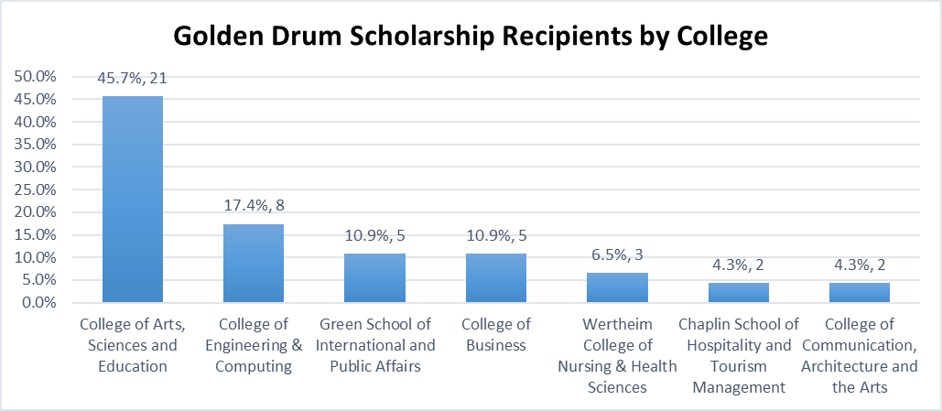

* Table 3 shows only the top 10 majors for Golden Drum recipients
  + Of the majors listed, Biology (41.7%) and Computer and Information Science (13.9%) account for over 55% of the top majors

Table 3: FT FTIC Golden Drum Scholarship Recipients by Top 10 Majors



* 89.1% (41) of Golden Drum scholarship recipients are Non-First Generation
* The number of First Generation scholarship recipients has remained the same since 2018-2019

Figure 2: FT FTIC Golden Drum Scholarship Recipients by First Generation Status

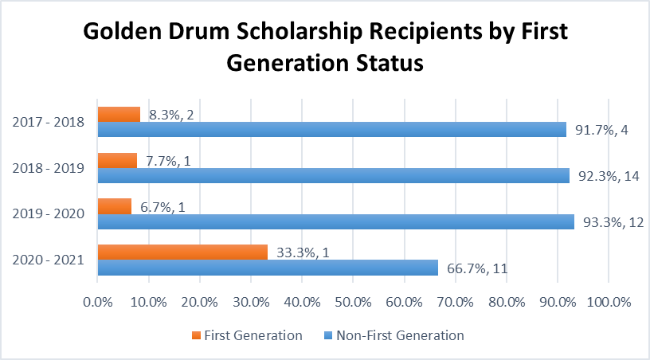

* 65.2% (30) of Golden Drum scholarship recipients also received the Pell grant at some point in their academic career
* The 2018-2019 and 2019-2020 cohort years had the highest number of students with the Pell grant (10)

Figure 3: FT FTIC Golden Drum Scholarship Recipients by Pell Status

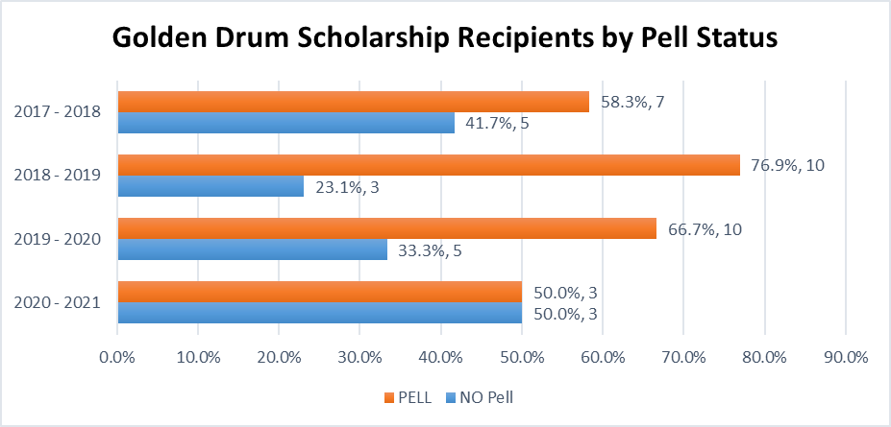

* Table 4 includes five cohort years and their average attempted credits and average earned credits. These are year-to-date numbers; therefore the 2016-2017 cohort are in their fifth year, the 2017-2018 cohort are in their fourth year, etc. The 2020-2021 cohort has the smallest amount of credits, both attempted and earned, because those students were in their first year at FIU.
* Compared to the university, Golden Drum Scholarship recipients and MPAS Scholarship recipients attempt more average credits
* Golden Drum Scholarship recipients were more successful in the percentage of earned credits than the university, except in the 2018-2019 cohort year
  + ($\frac{Earned Credits}{Attempted Credits})×100$
* Golden Drum Scholarship recipients earned 89-99% of the credits they attempted compared to the university’s 91-92%
* MPAS Scholarship recipients earned 92-98% of the credits they attempted which is also higher than the university’s average (91-92%)

Table 4: FT FTIC Total Credits Attempted and Earned – GD and MPAS vs FIU

|  |  |  |  |  |  |  |
| --- | --- | --- | --- | --- | --- | --- |
|  | Average Attempted Credits | | | Average Earned Credits | | |
| Cohort Year | Golden Drum | MPAS | FIU – (GD + MPAS) | Golden Drum | MPAS | FIU – (GD + MPAS) |
| 2016 – 2017 |  | 116 | 102 |  | 108 | 91 |
| 2017 – 2018 | 116 | 110 | 101 | 112 | 104 | 92 |
| 2018 – 2019 | 106 | 100 | 87 | 94 | 98 | 79 |
| 2019 – 2020 | 73 | 69 | 64 | 72 | 66 | 59 |
| 2020 – 2021 | 39 | 38 | 35 | 38 | 35 | 32 |

* Compared to the university, Golden Drum Scholarship Recipients have had a higher average cumulative GPA in the last four cohort years
* 2.2% (1) of students have a cumulative GPA below 2.0
* 65.2% (30) of students had a cumulative GPA of 3.5 – 4.0

Table 5: FT FTIC Golden Drum Scholarship Recipients by Cumulative GPA

|  |  |  |  |  |  |  |
| --- | --- | --- | --- | --- | --- | --- |
| Cohort Year | <2.0 | 2.0 - 2.49 | 2.5 - 2.99 | 3.0 - 3.49 | 3.5 - 4.0 | Grand Total |
| 2017 - 2018 | 0.0% | 0.0% | 0.0% | 33.3%  (n=4) | 66.7%  (n=8) | **100.0%**  **(n=12)** |
| 2018 - 2019 | 7.7%  (n=1) | 7.7%  (n=1) | 15.4%  (n=2) | 15.4%  (n=2) | 53.8%  (n=7) | **100.0%**  **(n=13)** |
| 2019 - 2020 | 0.0% | 0.0% | 13.3%  (n=2) | 20.0%  (n=3) | 66.7%  (n=10) | **100.0%**  **(n=15)** |
| 2020 - 2021 | 0.0% | 0.0% | 0.0% | 16.7%  (n=1) | 83.3%  (n=5) | **100.0%**  **(n=6)** |
| Grand Total | **2.2%**  **(n=1)** | **2.2%**  **(n=1)** | **8.7%**  **(n=4)** | **21.7%**  **(n=10)** | **65.2%**  **(n=30)** | **100.0%**  **(n=46)** |

Table 6: FT FTIC Golden Drum Scholarship Recipients Cumulative GPA vs FT FTIC FIU

|  |  |  |
| --- | --- | --- |
| Cohort Year | Golden Drum Scholarship Recipients | FIU |
| 2017 – 2018 | 3.77 | 3.19 |
| 2018 – 2019 | 3.26 | 3.24 |
| 2019 – 2020 | 3.59 | 3.34 |
| 2020 – 2021 | 3.75 | 3.44 |

* 97.8% (45) of scholarship recipients were retained in their second year with a GPA of 2.0 or higher
* Compared to the university, Golden Drum Scholarship recipients have higher 2nd year retention rates in the last four cohort years
* Only one student was not retained in the 2019-2020 cohort year

Figure 4: FT FTIC Golden Drum Scholarship Recipients by 2nd Year Retention (GPA>2.0)

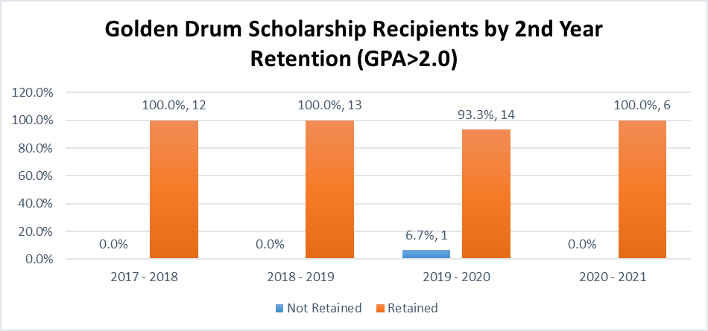

Table 7: FT FTIC 2nd Year Retention (GPA>2.0) Golden Drum vs FIU

|  |  |  |  |  |
| --- | --- | --- | --- | --- |
| Cohort Year | Golden Drum Scholarship Recipients | MPAS Scholarship Recipients | FIU – (GD +MPAS) | FIU |
| 2016 - 2017 |  | 100.0%  (N=1) | 86.6%  (N=4,151) | 86.7%  (N=4,152) |
| 2017 – 2018 | 100.0%  (N=12) | 100.0%  (N=28) | 87.8%  (N=3,445) | 87.9%  (N=3,485) |
| 2018 – 2019 | 100.0%  (N=13) | 93.8%  (N=16) | 88.0%  (N=3,906) | 88.1%  (N=3,935) |
| 2019 – 2020 | 93.3%  (N=15) | 100.0%  (N=27) | 90.1%  (N=3,263) | 90.2%  (N=3,305) |
| 2020 – 2021 | 100.0%  (N=6) | 95.8%  (N=24) | 89.0%  (N=2,706) | 89.1%  (N=2,736) |

**FT FTIC 4-year Graduation Rate**

* Golden Drum Scholarship recipients had a higher 4-year graduation rate in the 2017-2018 cohort year compared to MPAS Scholarship recipients and FIU
* MPAS Scholarship recipients had higher 4 year graduation rates in both the 2016-2017 and 2017-2018 cohort years compared to the university

Table 8: FT FTIC 4-year Graduation - Golden Drum and MPAS

|  |  |  |  |  |
| --- | --- | --- | --- | --- |
| Cohort Year | Golden Drum Scholarship Recipients | MPAS Scholarship Recipients | FIU – (GD +MPAs) | FIU |
| 2016 – 2017 |  | 100% (N=1) | 48.3%  (N=4,151) | 48.3%  (N=4,152) |
| 2017 – 2018 | 100.0%  (N=12) | 82.1%  (N=28) | 58.0%  (N=3,445) | 58.4%  (N=3,485) |

**MPAS Scholarship Analysis**

* MPAS recipients are mostly Female, except in the 2016-2017 and 2019-2020 academic years
* The 2017-2018 academic year had the largest group of Female scholarship recipients (25)

Table 9: FTIC MPAS Scholarship Recipients by Gender



* 54.6% (57) of scholarship recipients are Hispanic, followed by 35.6% (37) of Black or African American students
* Only 2.9% (3) of scholarship recipients are White

Table 10: FTIC MPAS Scholarship Recipients by Race/Ethnicity



* 45.2% (47) of scholarship recipients come from the College of Arts, Sciences and Education (CASE) followed by the College of Engineering and Computing (CEC)

Figure 5: FTIC MPAS Scholarship Recipients by College

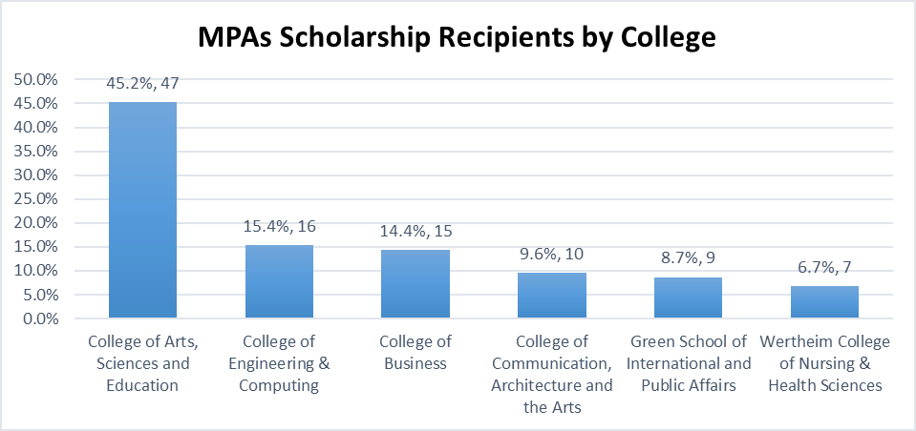

* Table 7 shows the top 10 majors for MPAS scholarship recipients
  + Of the majors listed, Biology (27.3%) and Psychology (16.4%) account for 43.7% of top 10 majors

Table 11: FTIC MPAS Scholarship Recipients by Major (Top 10)



* 70.2% (73) of scholarship recipients are Non-First Generation students
* The number of First-Generation students has fluctuated since 2016-2017, but they account for only 29.8% of total MPAS scholarship recipients

Figure 6: FTIC MPAS Scholarship Recipients by First Generation Status

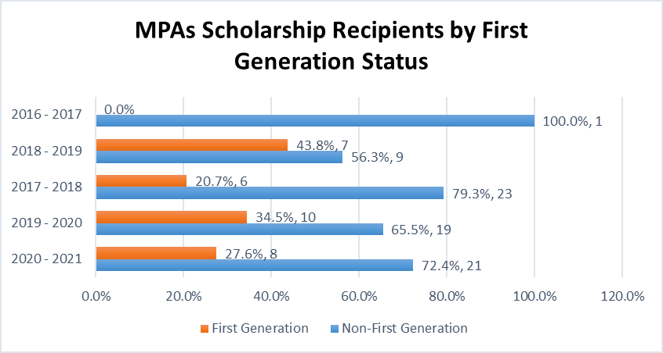

* 70.2% (73) of total MPAS scholarship recipients also received the Pell grant at some point in their academic career
* The number of scholarship recipients with the Pell grant has increased since 2016-2017, but fluctuate every year, with the highest being in the 2019-2020 academic year

Figure 7: FTIC MPAS Scholarship Recipients by Pell Status

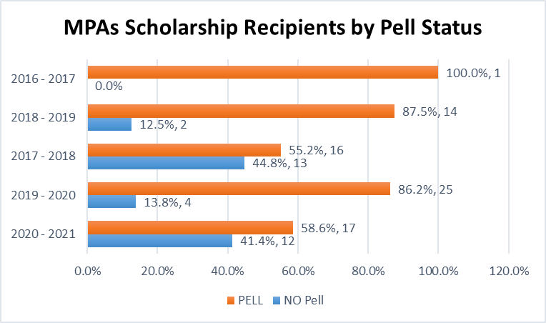

**Full-time First Time in College (FT FTIC)**

Retention and graduation rates involve only FT FTIC students who are labeled as cohorts because they were admitted in a Summer or Fall semester and were full-time students at the time of their enrollment. Of the 104 MPAS scholarship recipients from 2016-2017 to 2020-2021, 96 of them are cohorts. The 2nd year retention rates (Figure 8) are calculated by the total number of retained FT FTICs divided by the total number of FT FTICs. The 4-year graduation rates (Figure 9) were calculated similarly, however, only include the 2016-2017 and 2017-2018 cohort years since students in more recent cohorts haven’t had enough time to graduate within 4 years.

* MPAS Scholarship recipients had a greater cumulative GPA compared to the university except in the 2016-2017 and 2020-2021 cohort years
* 2.1% (2) of the total 96 FT FTIC scholarship recipients had a cumulative GPA below 2.0
* 83.3% (80) of students had a cumulative GPA greater than 3.0

Table 12: FT FTIC MPAS Scholarship Recipients by Cumulative GPA

|  |  |  |  |  |  |  |  |
| --- | --- | --- | --- | --- | --- | --- | --- |
| Cohort Year | <2.0 | 2.0 - 2.49 | 2.5 - 2.99 | 2.5 -2.99 | 3.0 - 3.49 | 3.5 - 4.0 | Grand Total |
| 2016 - 2017 | 0.0% | 0.0% | 0.0% | 0.0% | 100.0%  (n=1) | 0.0% | **100.0%**  **(n=1)** |
| 2017 - 2018 | 0.0% | 7.1%  (n=2) | 10.7%  (n=3) | 0.0% | 17.9%  (n=5) | 64.3%  (n=18) | **100.0%**  **(n=28)** |
| 2018 - 2019 | 0.0% | 0.0% | 0.0% | 0.0% | 37.5%  (n=6) | 62.5%  (n=10) | **100.0%**  **(n=16)** |
| 2019 - 2020 | 3.7%  (n=1) | 3.7%  (n=1) | 14.8%  (n=4) | 0.0% | 11.1%  (n=3) | 66.7%  (n=18) | **100.0%**  **(n=27)** |
| 2020 - 2021 | 4.2%  (n=1) | 8.3%  (n=2) | 4.2%  (n=1) | 4.2%  (n=1) | 16.7%  (n=4) | 62.5%  (n=15) | **100.0%**  **(n=24)** |
| Grand Total | **2.1%**  **(n=2)** | **5.2%**  **(n=5)** | **8.3%**  **(n=8)** | **1.0%**  **(n=1)** | **19.8%**  **(n=19)** | **63.5%**  **(n=61)** | **100.0%**  **(n=96)** |

Table 13: FT FTIC MPAS Scholarship Recipients Cumulative GPA vs FT FTIC FIU

|  |  |  |
| --- | --- | --- |
| Cohort Year | MPAs Scholarship Recipients | FIU |
| 2016 - 2017 | 3.05 | 3.11 |
| 2017 – 2018 | 3.41 | 3.19 |
| 2018 – 2019 | 3.61 | 3.24 |
| 2019 – 2020 | 3.40 | 3.34 |
| 2020 – 2021 | 3.41 | 3.44 |

* 97.9% (94) of FT FTIC MPAS Scholarship recipients were retained in their second year with a GPA of 2.0 or higher
* Only two students in the 2018-2019 and the 2020-2021 cohort years were not retained
  + One Black or African American Male student and one Black or African American Female student

Figure 8: FT FTIC MPAS Scholarship Recipients by 2nd Year Retention (GPA>2.0)

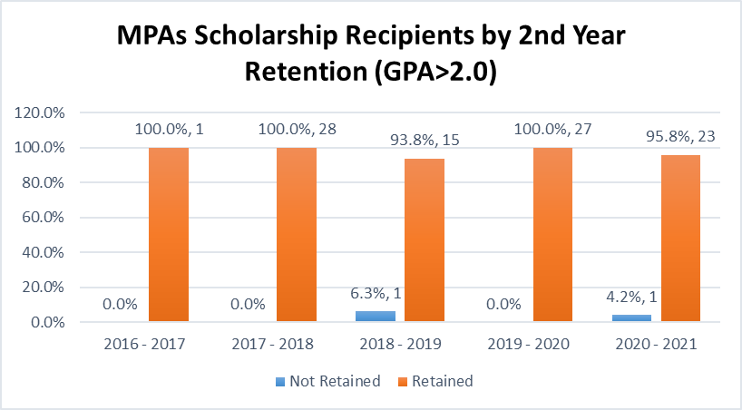

Table 14: FT FTIC 2nd year Retention (GPA>2.0) MPAS vs FIU

* 82.8% (24) of the 29 total FT FTIC scholarship recipients in the 2016-2017 and 2017-2018 cohort years, graduated within 4 years
* Five students did not graduate
  + These students were all Non-First Generation Hispanic or Black or African American Female students
  + Two out of the five students had Pell at some point in their academic career

Figure 9: FT FTIC MPAS Scholarship Recipients by 4yr Graduation Rate

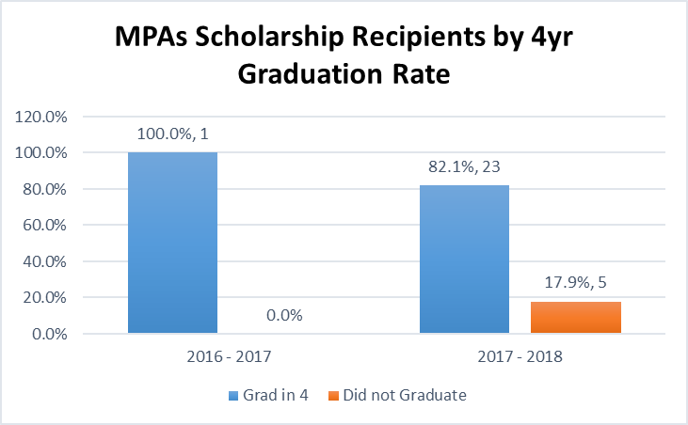

1. All Golden Drum scholarship recipients were FT FTIC (cohort students)