College Credit Earned (CCE)
STUDENT MANUAL

Table of Contents
Accessing the CCE Form: 3
Step 1 - Introduction 3
Step 2 – Academic Information 4
Step 3 – Career Interests 5
Step 4 – Incoming College Credits 6
Step 5 – Supporting Documents 10

The College Credit Earned form, or CCE, will let your orientation advisor know what college credits/test scores you may already have or will be transferring in; any career interests you have and will let you upload unofficial transcripts or test scores.

Information entered on this form is being saved as you navigate through the different pages. You will be able to enter information and upload any supporting documents (e.g., test scores, unofficial transcripts). Once you have provided all pertinent information, the last page will allow you to submit the form for your advisor to review and use to guide you forward. Please submit the form even if you do not have any incoming college credits. Once submitted, the form will become unavailable, and you will not be able to make any further changes.

If you are not admitted to a fully online program, please register for an in-person orientation. More info at orientation.fiu.edu.

Accessing the CCE Form:  To access the CCE Form, login via my.fiu.edu and proceed to log using your FIU username or Panther ID and password.  Once you have logged in, click on the Academic Advising tile. From there, then click on the CCE Form tile to start filling out the form.  (*Note: Once you have completed the CCE Form, you will only be able to see it in Read-Only mode. If you need to add or edit any information, please let your advisor know at your appointment. If you cannot access your CCE Form, please contact fiuadvising@fiu.edu) | 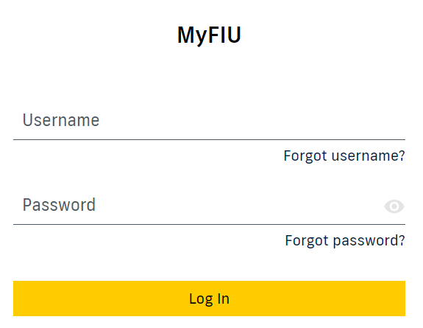  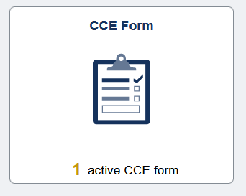
Step 1 - Introduction  In this initial step, you will need to review that all your information is correct. If your orientation is blank and you are not a fully online student, please register for an in-person orientation. More info at orientation.fiu.edu. If any of your information is incorrect on this page, please contact fiuadvising@fiu.edu.  Once everything has been verified, click on Next to continue to Step 2. | 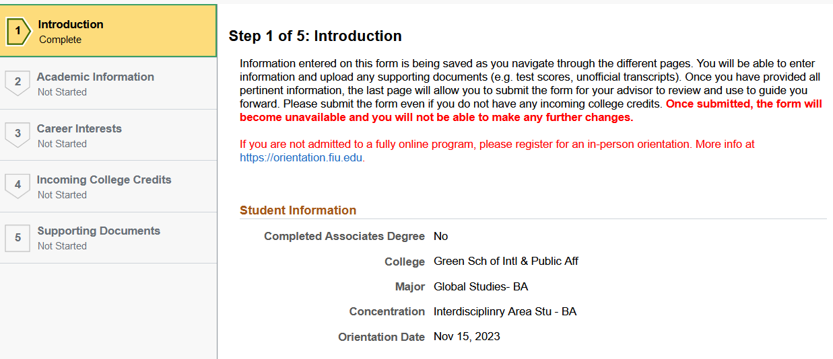
Step 2 – Academic Information  In this step, you will alert your advisor if you have an AA (Associate in Arts) transcript that is pending to be sent to FIU by toggling the button from No to Yes. You will then be prompted to enter the name of the institution if you change it to Yes.  If you do not have an AA Complete Transcript pending, leave the button set to No.  If you have been accepted to FIU Honors College, toggle the button from No to Yes.  Once everything has been verified, click on Confirm and then click on Next to continue to Step 3. | 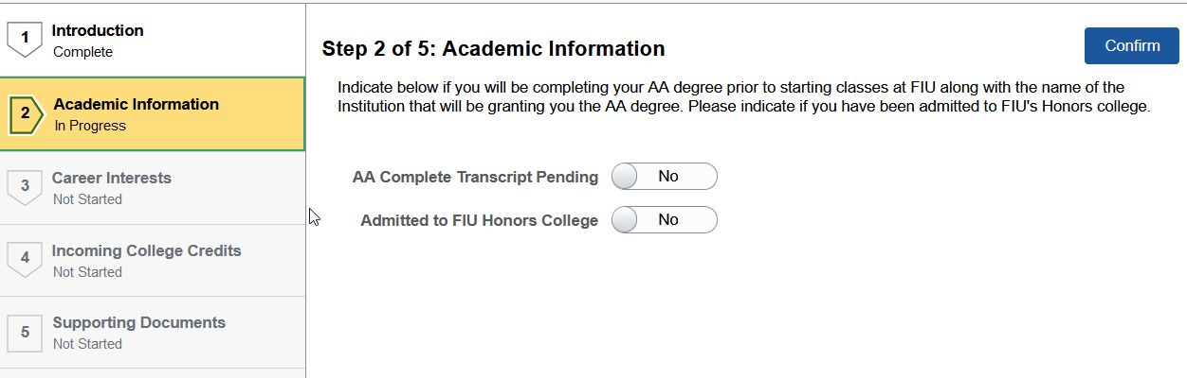
Step 3 – Career Interests  In this 3rd step, you will be asked to select which Pre-Professional interest you may have, if any. Multiple selections are possible for certain combinations. Selecting Pre-Nursing will exclude all other options except Pre-Occupational Therapy. Likewise, Pre-Law will allow you to select any other career interest except Pre-Nursing.  To select your interests, first toggle the button to “Yes” and then do the same for each Pre-Professional interest you may have.  Once everything has been verified, click on Confirm and then click on Next to continue to Step 4. | 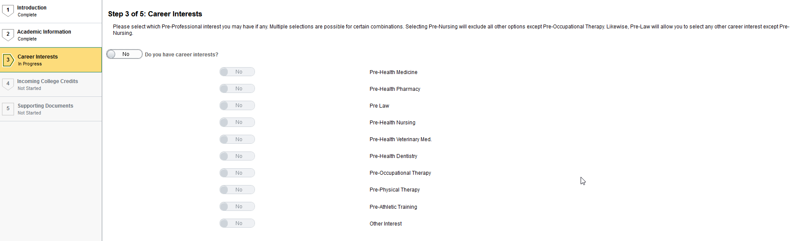  
Step 4 – Incoming College Credits  In this 4th step, you will be reviewing which transfer and test scores the university has received and posted to your academic record, as of the moment you are filling out this form. If you notice you are missing any test or transfer course information, you are given the option to self-report these. In the next step you will be asked to upload any supporting documentation.  To self-report a test or course information, toggle the button to “Yes.” This will change your screen and now display a new button that will allow you to add them one by one.  You will have the option to enter Course Credit or Test Credit by selecting the appropriate one from the drop-down menu next to Earned External Credits  If entering a Course Credit - a college course taken at a higher education institution other than FIU - please enter:  - Name of Institution à where the course is being transferred from  - Course à what is the course prefix and number. For example, ENC1101  - Grade à what grade did you receive or expect to receive in the course  - Grade/Score Status à this is defaulted to Final if you have completed the course. If you are In Progress, please toggle the button to In Progress  Once you have entered all the information, click on Save.  If entering a Test Credit – an advanced course taken at a high school, such as AP, IB, AICE, CAPE, and others - please enter:  - Test Component à what is the name of the test you took (see below for assistance on how to look up the test name)  - Expected Score à what score did you receive or expect to receive  - Grade/Score Status à this is defaulted to Final if you have completed the course. If you are In Progress, please toggle the button to In Progress  If you need assistance in looking up the Test Component name, click on the magnifying glass. You will be brought to a new page to help with your search. From the drop-down menu, change the option from begins with to contains. This will allow you to search for any part of the test name if you are unclear how it is spelled out. In this example, English was written in the search field and then the Search button was selected to show all the results with the word English somewhere in the title. Once you have found the correct test, simply select it and you will be brought back to the previous screen.  Once you have entered all the information, click on Save.  Once you are done reviewing and/or entering self-report credits, click on Confirm and then click on Next to continue to Step 5. | To make the most of your advising session, it is crucial you list out everything in this step even if you do not know your score or grade yet.  Please make sure to include any test credits (e.g., Advanced Placement (AP), Cambridge AICE, International Baccalaureate (IB)), and/or any Dual Enrollment courses, or college courses taken at other institutions. If your scores or grades are pending, enter the score or grade you think you earned. Be sure you mention this to your advisor.  To see possible course equivalents visit transfer.fiu.edu/transfer-101/ted/  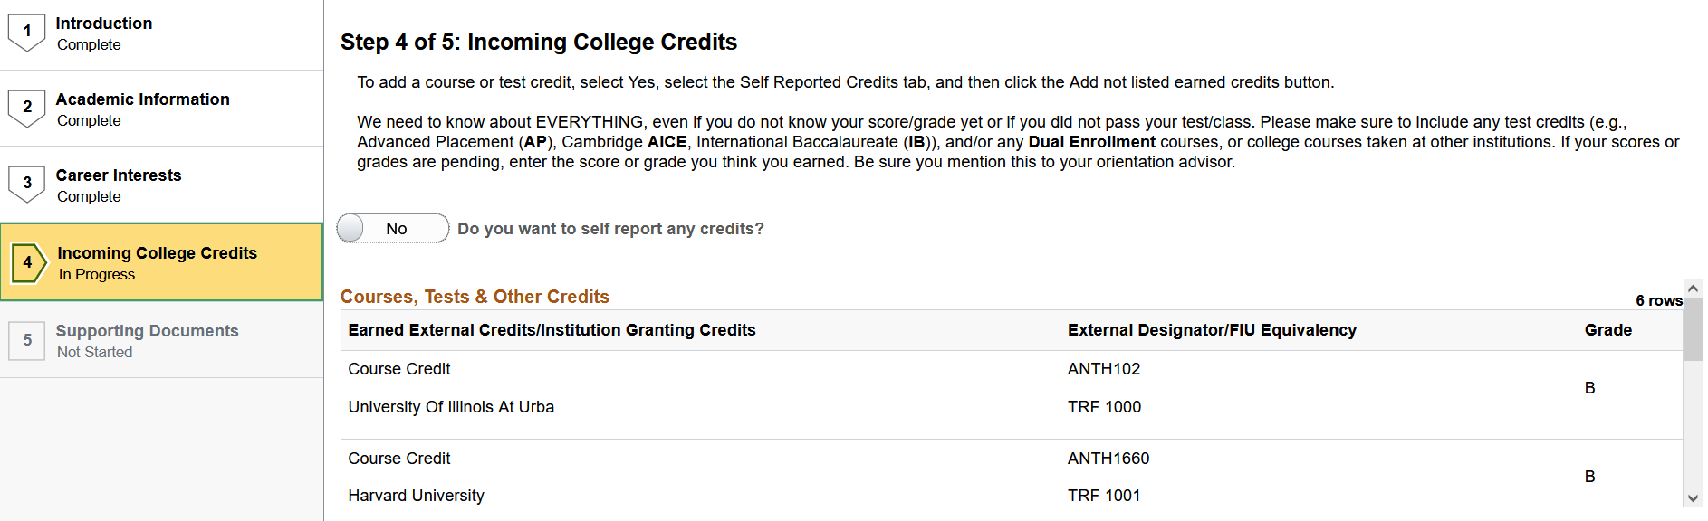      This option below will appear only AFTER you have self-reported your first course or test score. You would click on the + button to add more entries.    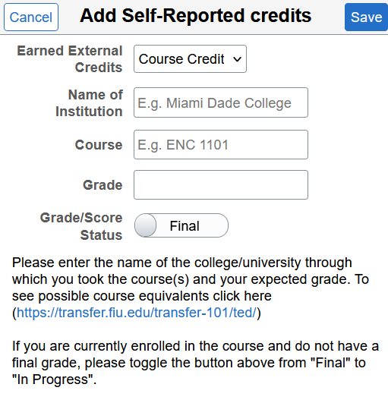  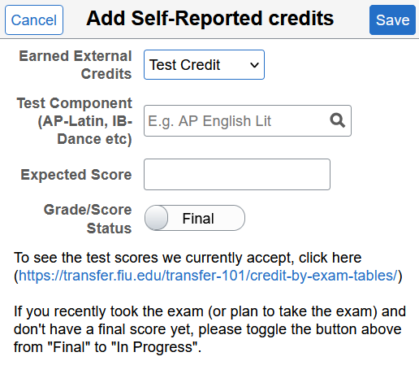  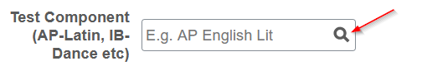  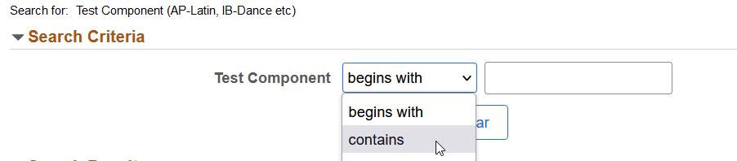  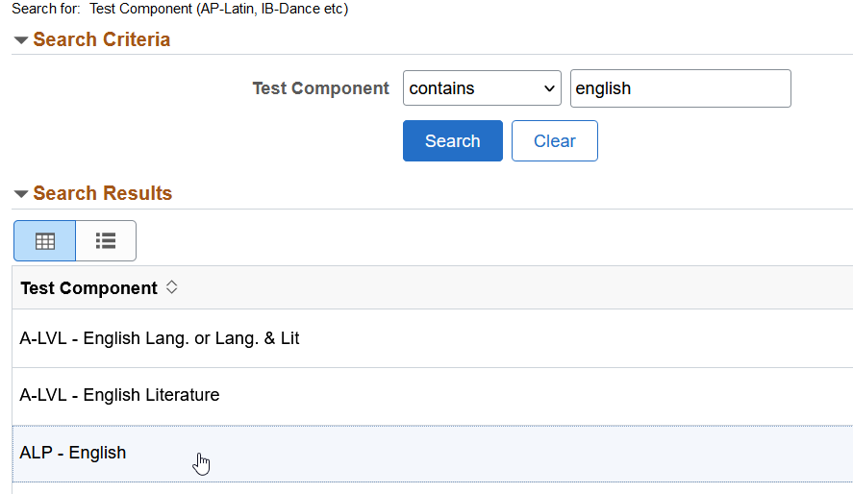

Step 5 – Supporting Documents  In this last step, you must submit supporting documentation to your advisor for any course credits or test scores that you just self-reported. Accepted file types are .pdf, .png and .jpg. Please do not upload high school transcripts on this page; only college transcripts or score certificates are required.  Once you click the Submit button, the form will no longer be available for editing, and you will not be able to make any changes.  (*Note: if you self-reported any course credits or test scores, you will be required to upload supporting documentation before clicking on Submit)  Once everything has been submitted if needed, click on Submit to complete your CCE Form. | 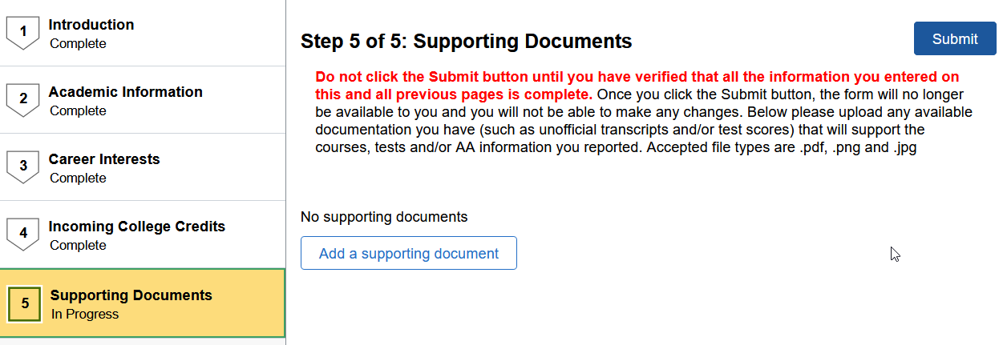

If you have questions after reviewing this tutorial, please contact fiuadvising@fiu.edu.

